Employee Work Status Report
Name: Date:
Date of illness / injury: DOB:
Please describe the medical facts that affect the employee’s ability to work:

The following medical information will apply until the next evaluation appointment on
(Date)
 Regular work as of

 Can work with the following medical restrictions as of

Not At All Occasionally Frequently Continuously

 Lifting ____ lbs. Max    
 Pushing / Pulling ____ lbs. Max    
 Climbing Stairs / Ladders    
 Over The Shoulder Work    
 Use Of Right Arm / Left Arm    

 Standing / Walking ___ hrs. with break every __________
 Sitting Job Only
 Bending, Stooping, Twisting  Not At All  As Tolerated

Hands Used For Repetitive Actions

 Right Hand  Left Hand
A. Simple / Light Grasping    
B. Firm Strong Grasping    
C. Fine Dexterity    

Use:  Splint  Sling
 Crutches  Comfortable Shoes  Ace Wrap
 Driving to and from work only
 No driving (vehicle or equipment / machinery)
 Other __________________________________

 Incapacitated from to .
(Date) (Date)
 Physical Therapy .

Comments:
Sign Here
(Examining Physician Signature) (Date)

Physician
Name: Phone:
Physician
Address: Fax:

Workers’ Comp
Benefits
Return to: Airborne Express
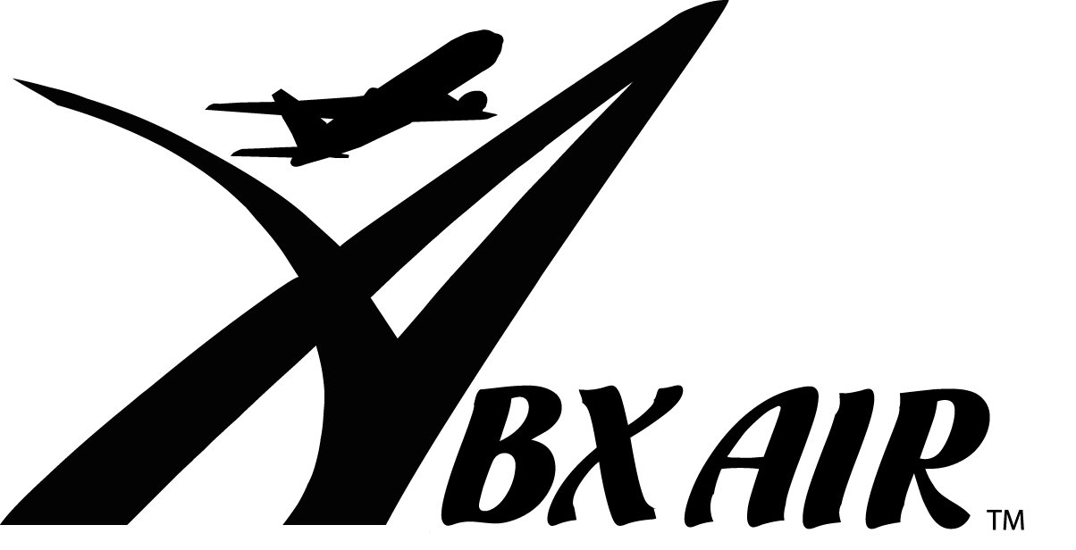
Attn: Human Resources, 2061-B
145 Hunter Drive
Wilmington, OH 45177
Phone: (937) 382-5591
Fax: (937) 382-3056 input.doc
Employee Work Status Report
Name: Date:
Date of illness / injury: SS#:
Please describe the medical facts that affect the employee’s ability to work:

The following medical information will apply until the next evaluation appointment on
(Date)
 Regular work as of

 Can work with the following medical restrictions as of

Not At All Occasionally Frequently Continuously

 Lifting ____ lbs. Max    
 Pushing / Pulling ____ lbs. Max    
 Climbing Stairs / Ladders    
 Over The Shoulder Work    
 Use Of Right Arm / Left Arm    

 Standing / Walking ___ hrs. with break every __________
 Sitting Job Only
 Bending, Stooping, Twisting  Not At All  As Tolerated

Hands Used For Repetitive Actions

 Right Hand  Left Hand
A. Simple / Light Grasping    
B. Firm Strong Grasping    
C. Fine Dexterity    

Use:  Splint  Sling
 Crutches  Comfortable Shoes  Ace Wrap
 Driving to and from work only
 No driving (vehicle or equipment / machinery)
 Other __________________________________

 Incapacitated from to .
(Date) (Date)
 Physical Therapy .

 Functional Capacity Evaluation and On-Site Work Reconditioning
(Lifting restrictions must be removed for the purpose of evaluation and rehabilitation.)
Comments:
Sign Here
(Examining Physician Signature) (Date)

Physician
Name: Phone:
Physician
Address: Fax:

Workers’ Comp
Benefits
Return to: ABX Air, Inc.
Attn: Human Resources, 2061-B
145 Hunter Drive
Wilmington, OH 45177
Phone: (937) 382-5591
input.doc Fax: (937) 382-3056

